Portfolio of Web sites

1 Sites to Develop

The three sites that I will be designing under the categories are:

E-Commerce | A Web site that sells rock/metal band merchandise.
Information/community of interest | A Web site for car enthusiasts of a particular make and model – SEAT Arosa.
Education | A site to assist students preparing to undertake GCSE revision.

2 User Profiles

User profiles establish the general requirements of a category of users in respect of the overall interface style and interaction approach. User profiles for each of the three sites are shown in Figures 2-1, 2-2 and 2-3 detailing the main characteristics of the user group.

GENERAL PROFILE
The users will mainly teenagers and young adults (18-30) of both genders into the rock/metal music scene. However, some of the users may be visiting the site to buy items for someone else and could be much older and not into the music scene at all. The users can range from novice to experts in their computing skills.

USER CHARACTERISTIC | SCORE (scaled 1 {very low} – 5 {very high})
Psychological characteristics:  Attitude  Motivation | 4/5  4/5
Knowledge & experience:  Computing skills  Task experience | 2-5  3
Task characteristics:  Frequency of use  Task structure-complexity | 2-4  3 (some guided navigation, most ‘free’)
Physical characteristics:  Visual impairment  Dyslexia | Unknown  Some individuals: 3-5
Figure 2-1: User profile for Site 1

GENERAL PROFILE
The users will be a distinct small niche market that has the specific (quite rare) car the site caters for or those interested in getting the car. They will be of mixed gender and could be any age but primary young adults. Frequency of use will be higher than that of the online shop as the small user community will be able to interact via a forum for example. The users can range from novice to experts in their computing skills.

USER CHARACTERISTIC | SCORE (scaled 1 {very low} – 5 {very high})
Psychological characteristics:  Attitude  Motivation | 4/5  4/5
Knowledge & experience:  Computing skills  Task experience | 2-5  3
Task characteristics:  Frequency of use  Task structure-complexity | 3-5  3 (some guided navigation, most ‘free’)
Physical characteristics:  Visual impairment  Dyslexia | Unknown  Some individuals: 3-5
Figure 2-2: User profile for Site 2

GENERAL PROFILE
The users will be high school students of mixed gender aged 15/16 in year 10/11 preparing for their GSCE’s. The users will be reasonably well educated being at school and can range from novice to experts in their computing skills. All will be at least computer literate having used computers in school.

USER CHARACTERISTIC | SCORE (scaled 1 {very low} – 5 {very high})
Psychological characteristics:  Attitude  Motivation | 3/4  4/5
Knowledge & experience:  Computing skills  Task experience | 3-5  3/4
Task characteristics:  Frequency of use  Task structure-complexity | 2-4  3 (some guided navigation, most ‘free’)
Physical characteristics:  Visual impairment  Dyslexia | Unknown  Some individuals: 3-5
Figure 2-3: User profile for Site 3

3 Task Analysis

Figures 3-1, 3-2 and 3-3 list all the tasks that the target users should be able to carry out on each of the three sites.

View band merchandise by categories (hoodies, t-shirts, music, posters, and badges) and sorted by bands.
See images of clothing from different views (e.g. front and back designs)
Hear sound clips of band music available
Select sizes for clothing items
See recommended items/personalization features
Read customer reviews on products sold
Read about the company
Contact the company – customer support
Read information regarding delivery & returns
Learn about privacy and security measures on the site
Enter their address and payment details (different payment methods)
Purchase items
Track their order
Figure 3-1: Task analysis for Site 1

Join the site/register
Interact with other members of the forum (inc. organising actual meets)
View technical information (and images) about the each model of the specific car the site caters for
View details about the site owners car including images, tech spec, future plans, etc
View information regarding modifications to the car including exterior and interior styling and performance tuning.
Contact the site owner (and other members)
View details about enthusiasts cars that have been submitted to the site.
Submit their own car images and details to be displayed on the site
Have a wide range of relevant external links available to them (e.g. alloy wheel manufacturers)
Advertise their cars and relevant parts for sale
Figure 3-2: Task analysis for Site 5

Read hints and tips regarding exams and revision techniques
View modular revision material for each of the subjects the site caters for
Test themselves on the revision material via online tests with feedback
View past exam papers
Contact the people behind the site
Possibly interact with other students via a forum

Figure 3-3: Task analysis for Site 3

4 Requirements/Specification

Now the users groups have been identified and a basic task analysis carried out for each of the sites, a clear set of requirements will be detailed. These have been broadly split into two categories – content and design and will drive the design and implementation process.

4.1 Content

All of the sites will have to be easy to navigate and the content organized such that users can easily find what they need. Consistency is important and clear links back to important information on every page should be present.

Content organisation with in a web site is one of the most important factors when looking at web site usability. (Nielsen, 1999) Reading from a monitor isn’t very comfortable and most people want to make it as short an experience as possible. One of the key factors in making the site a success will be the ability to create well-written content that keeps users engaged. Bulleted lists should be used where necessary as they can be a useful way of summarising content and creating white space on the screen. Sentences and paragraphs need to be concise.

Scrolling will have to be kept to a minimum by structuring the content effectively into sections and using anchors. Long pages are confusing on screen and should be left for print. Plus unnecessarily long pages would fail to take advantage of the linkages available in the Web medium.

A content inventory for each of the sites is shown in Figures 4-1, 4-2 and 4-3.

A very important feature to consider with the e-learning site is retention of information. People recall information more easily when it has been absorbed through abstract methods, such as images or interaction, rather than just plain text that has been read. Studies have shown that people recall only 10% of information that they have merely read yet they can recall 70% of information that has been absorbed after seeing, hearing and interacting with it (The Learning Group, online). The online tests will allow this vital interaction rather than just a reading load of revision material.

A forum was decided not to be included in Site 3 as it would most likely distract the users from the main purpose of the site which is to revise for their exams.

Section | Sub-sections | Additional Notes
Shop | - T-Shirts  - Hoodies  - Music  - Posters  - Badges | - All merchandise categories will be sorted into bands.  - Good quality images provided including alternative views of items (e.g. front & back T-Shirt designs)  - Ability to select different clothing sizes  - Music clips provided for some of the CD’s sold & track listings shown.  - Customer reviews of products available  - Personalisation features such as recommended items incorporated  - Prices clearly labeled and a BUY button that stands out well.  - A search facility will be provided.
Cart |  | - Shipping options (UK, Rest of World)  - Ability to select quantities & recalculate total price  - Continue shopping link  - Proceed to checkout link
Checkout | - Enter Delivery Details  - Enter Payment Details  - Order Confirmation | - Payment methods: all major credit/debit cards & Paypal.  - Email confirmation of order sent  - Users have the ability to track their order  - Personal details logged
Help | - About Us  - FAQ  - Delivery  - Returns  - Privacy  - Security  - Contact | - Contact form provided
Figure 4-1: Content inventory for Site 1

Section | Sub-sections | Additional Notes
Arosa Spec | - 1.0  - 1.0 S  - 1.4 S  - 1.4 16v Sport  - 1.7 HDi | - Detailed specifications for each model in the range including images.  - Links to reviews on the car.
Mods | - Exterior Styling  - Interior Styling  - Performance Mods  - ICE | - Images provided for all the modifications available.
My Car | - Why Got It  - Modifications  - Future Plans | - Numerous images provided of my car.
Your Cars | - Mk1  - Mk2 | - Images (max of 6, 320 by 240 pixels) and a modification list provided for all cars  - Members email optionally shown purely so other members can contact them.  - Ability to submit own cars via email (instructed to blank out reg.plates)
Forum | - General Chat  - Meets  - Modifications  - Problems  - For Sale/Wanted | - Register before using the forum.  - Ability to alter personal details and various other features such as private messages and new forum posts.
Links |  | - Include a wide range of relevant external links.
Contact |  | - Contact form provided

Figure 4-2: Content inventory for Site 2

Section | Sub-sections | Additional Notes
Subjects | - Maths  - Revisions  - Tests  - English  - Revision  - Tests  - Science  - Revision  - Tests  - ICT  - Revision  - Tests | - Revision material and sample tests provided for all subject modules.  - Feedback given with the tests.
Hint & Tips | - Revision  - Exams
Figure 4-3: Content inventory for Site 3
4.2 Design

All the sites should be designed in a style that will appeal to the identified target audience's tastes and make the interface pleasurable to use. There should be continuity in the design between different pages and sections of the site. The goal is to be consistent and predictable so that the users should feel comfortable exploring the site and confident that they can find what they need. Pages should not be cluttered as information overload can cause discomfort and prevent users from finding the information they want to find. White space on a screen can make it easier to see the important parts of the site.

Without the visual impact of shape, colour, and contrast, pages are graphically uninteresting and will not motivate the viewer. Dense text documents are also harder to read, particularly on the relatively low-resolution screens. A balance has to be made between graphics and textual content. Contrast, repetition, alignment and proximity will all have to be taken into consideration in the page design.

The site design should reflect the required image of the site accurately by effective use of colours and images.

 | Site 1 | Site 2 | Site 3
Colour Scheme | Dark  -Black, white, red. | Bright  -White, red | Bright  -White, blue, red, green, orange
Header Design | Include a relevant image to metal music such as flames, skulls or even a band, etc | Incorporate the car the site caters for | Simple to avoid distraction from the main content

Flash will not be used on any of the sites as when it works the results are powerful (e.g. http://www.balthaser.com and http://www.eye4u.com/home/), but there is a tendency to misuse Flash. It often takes too long to load and when it does it presents numerous accessibility and usability problems that can further frustrate the user delaying their ability to get what they came for.

5 Legal/Professional Issues

This section briefly discusses legal / professional issues that have to considered & addressed with each of the sites if they were fully implemented.

Firstly considering all the sites, it is imperative they are accessible to as many users as possible. Both technology-disabled users and physically disabled users need to be taken into consideration. There are laws in place concerning accessibility issues, and they now relate to online service providers. Part III of the Disability Discrimination Act of 1995 highlights issues related to website design and accessibility.

Features the sites should include are text-only versions of content (to aid blind users for example using screen-readers), printable versions, no unnecessary plug-ins, accesskeys for main navigation buttons (to aid those with motor difficulties), resizable text and no contrast, layout or any browser issues that affect readability. Plus download times and the amount of scrolling need to be reasonable.

Other relevant legal issues to be considered include Data Protection. Under this Act, the websites have a legal duty to protect any information collected from the users. This will have to be especially considered on Site 1 (the e-shop) as it will be collecting personal information such as address and payment information. A Data Protection or privacy statement should be included on the site. On Site 2 the users can submit images of their cars. The registration plates should be blanked out of these images either by the user or the web master. Site 3 – the e-learning site does not collect any information from the users. No unnecessary cookie information should be collected on any of the sites either without informing the users.

If a forum was implemented on any of the sites then many legal and professional issues would have to be considered including Data Protection, Intellectual Property, Copyright, unethical/immoral use, etc. The personal details users provide when they register will have to be kept private except to comply with applicable laws or valid legal reasons. The content of a large forum would have to be moderated and a clear set of rules provided for the users such as no inappropriate language or images. Members will be warned and even banned if they do not adhere to the rules clearly presented. Copyright issues will have to be considered with the content users submit.

Specifically with Site 1 as an e-shop security needs to be considered as it is a critical aspect of e-Business with legal requirements. Measures will have to be taken to lessen the risk of intrusion into corporate networks and web-sites. Additionally, the security of transactions is vital to consumers’ confidence. The company can protect themselves and their customers by using a firewall, authentication and authorisation mechanisms (secure login in systems, restricted access to databases, etc). To increase the customers trust in buying online from them, the secure payment mechanisms (using SET protocol) need to be stressed.

Copyright issues will have to be taken into account on Site 1 as official band merchandise will be sold. The site will have to ask permission from the band managers and other relevant people if they can display the content. With Site 2, many images will be used in the modifications section such as images of body kits. Wherever these are obtained, permission will have to be granted first. Regarding Site 3 copyright issues will have to be carefully taken into account if the revision and test information has been obtained from another source such as an official GCSE revision booklet for the subject.

6 Design & Implementation

This section presents a sitemap and wire-frames for each of the sites. Reasons for design ideas are also described. Screenshots of the implemented sites are shown and alterations from the original designs noted. A basic technical description on how the sites are coded and structured is also given.

Site 1

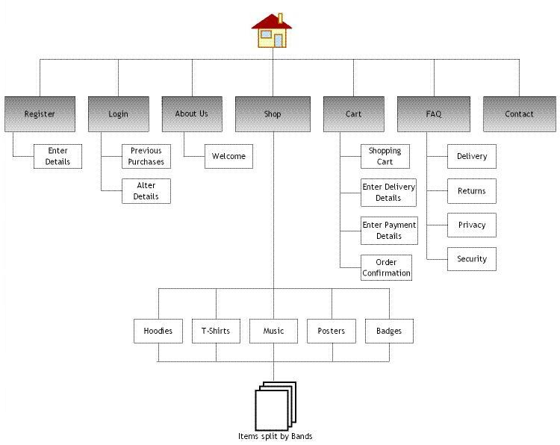
Figure 6-1: Basic sitemap for Site 1

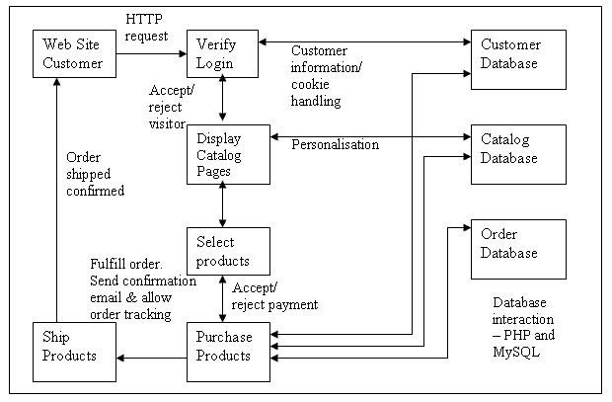
Figure 6-2: Specific e-Shop structure/process for Site 1 (Based on Laudon and Traver, E-commerce, 2004 p 200)

Figure 6-1 shows the basic sitemap for Site 1, while Figure 6-2 goes into more detail illustrating the specific e-shop structure/process.

The homepage design illustrated in Figure 6-3 shows that the layout is simple yet very effective. All the separate elements of the design have been clearly separated with the side bar links all grouped in the right column organised into separate sections, the main content to the left and the header at the top. Effective use of borders throughout the layout reinforces this separation and makes the design look particularly neat and professional. Effective use of repetition and contrast has also been used within this design with the black and white separate elements of the layout. This consistency in the design makes it easy on the eye and avoids any confusion.

This category page of the shop shown in Figure 6-4 uses thumbnails to show all the products available. These can be clicked for further information and to purchase the item. Again effective use of repetition has been made in the design. Figure 6-5 illustrates a detailed item page. Good use of strong left alignment has been adopted in the layout. The user can easily select a different view of the product and effective use of proximity makes the price and BUY button stand out.

Figure 6-6 shows the implemented site. The header image is effective and fits with the purpose of the site well. It is a ‘skeleton rocker’ placed on the back of a T-Shirt. The opacity of this image has been reduced to about 50% so it blends into the background more effectively and doesn’t take emphasis away from the name of the site displayed in red text. The font used for this text is called ‘Stencil’ and fits the overall image very well. This sort of font has been used in the Attitude Clothing magazine (see design book) and various other rock music related media. A flames background was also designed and tested but this looked over the top and the text was slightly difficult to read.

Grey text has been used rather than black as planned in for the main content as it looks neater and easier on the eye. Separators have been used on the side bar links so that they stand out more effectively. Login/register links have not been included in the design simply as these pages have not been implemented. Furthermore, small online stores don’t always keep user accounts. On the FAQ page, use of a small amount of JavaScript has enabled a neat design that makes efficient use of the page space. The main headings can be clicked and the content is then displayed in a drop-down section.

Overall this design is relatively simple but sleek and professional with effective use of repetition and contrasts in the design. Plus, the dark colours and images portray the image required very well.

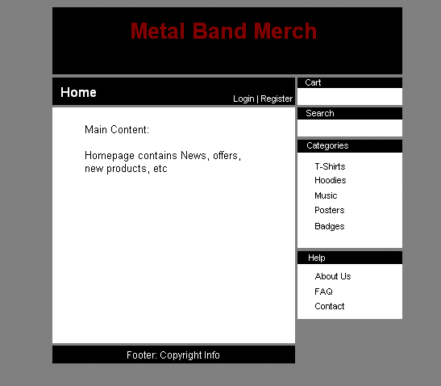
Figure 6-3: The homepage design for Site 1
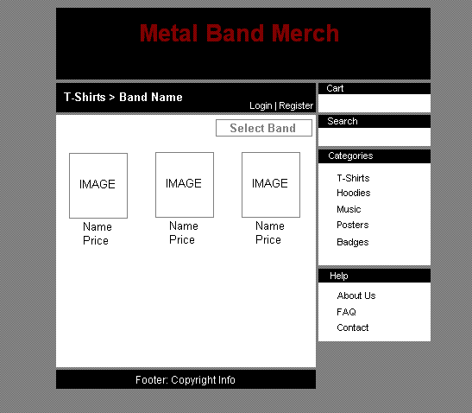
Figure 6-4: The T-Shirt category page of the shop for Site 1
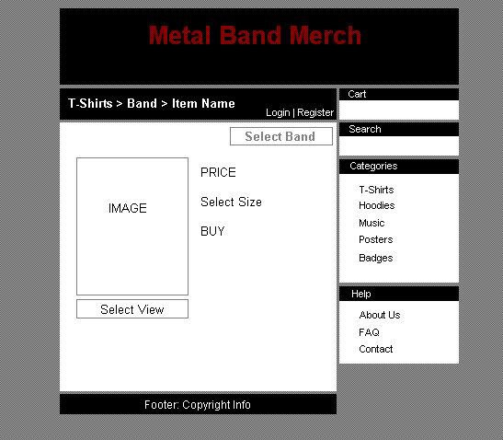

Figure 6-5: Design for a detailed item page with Site 1

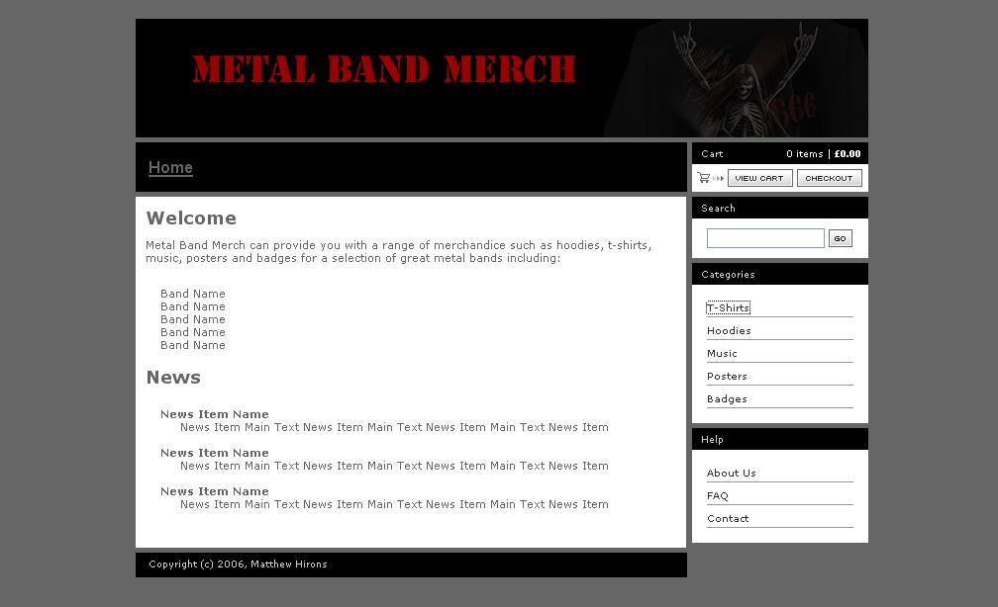
Figure 6-6: The homepage of the implemented Site 1

Site 2

Figure 6-7 shows the basic sitemap for Site 2.

As shown in Figure 6-8, this design follows a simple layout clearly separated into sections with the header, the navigation bar, main content and the footer. The bold colour scheme is effective and looks professional only using a small selection of contrasting colours. There are no problems with readability either. Although the design seems relatively basic, an interesting and striking header image sets it off effectively as shown in the implemented site (Figure 6-11). The creative header design makes the site instantly visually appealing and the users will know straight away what the site is about as a large image of the car the site caters for is included in the header. This car image has a ‘vignette’ effect round it and a ‘lizard skin’ effect over the top of the whole design. The text for the site name text is still clearly readable in white with a drop shadow though. Many effects were tested on this header design but some were too overwhelming and did not suit the overall image of the site.

Rollover buttons have been used for the navigation bar that change from red to black (with white text). Furthermore a translucent effect has been used on this navigation bar to neatly blend in with the header design. Readability has not been particularly hindered either.

Figure 6-9 illustrates the design for the car specifications page. One again, an effective use of strong alignment and repetition has been used in the layout. The text floats neatly around the images with some padding. The car images can be clicked on for further information specific to each model. Figure 6-10 shows the design of the Your Cars section. An interesting layout as a grid of owners’ cars is stylishly displayed by including alternating red and black blocks between the car thumbnail images. These images can be clicked for more information about the cars. However, this design was significantly altered when implemented to make more efficient use the page space; more cars could be displayed on the screen. Furthermore the original design may have seemed confusing on the eye for some users. A picture frame effect has been applied to all the car thumbnail images to highlight them in the implemented page.

A neat use of the ‘fieldset’ and ‘legend’ tags (plus relevant CSS) has been included for various elements of the design such as the news items on the main page and the contact form. If no CSS was applied to the contact form it would look relatively dull and boring and not fit the rest of the design that well.

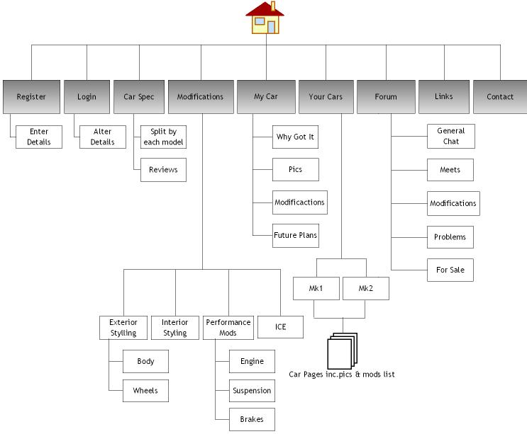

Figure 6-7: Basic sitemap for Site 2
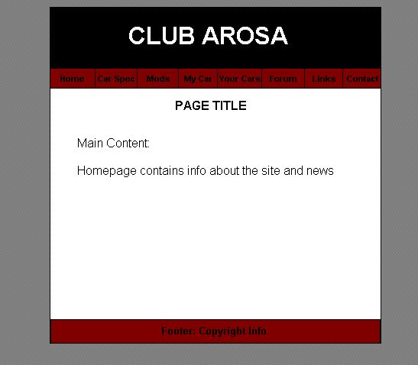
Figure 6-8: The homepage design for Site 2
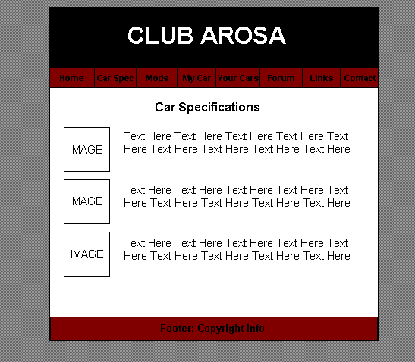

Figure 6-9: The design for the car specifications page
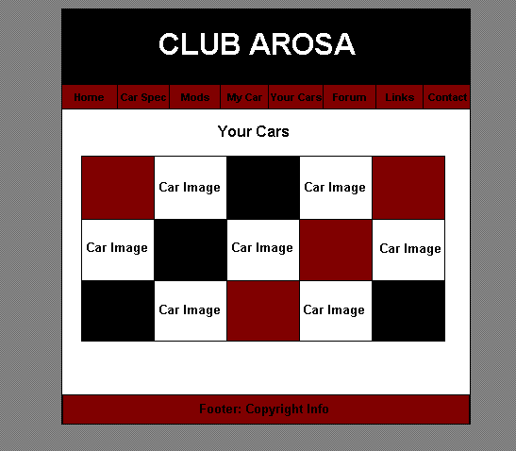

Figure 6-10: The design of the Your Cars section

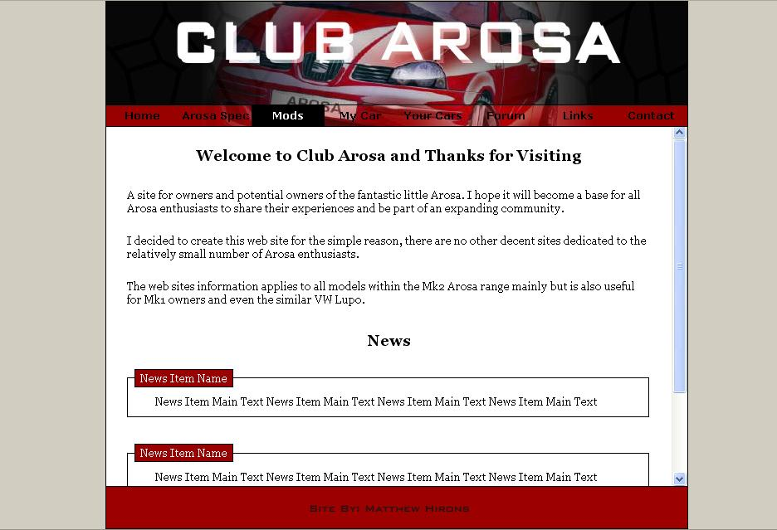

Figure 6-11: The homepage of the implemented Site 2

Site 3

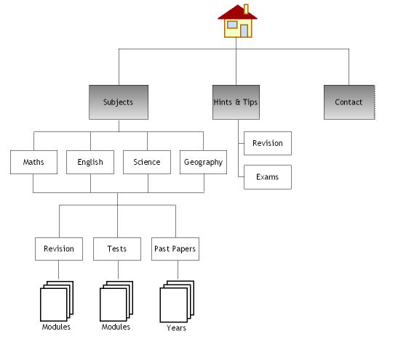
Figure 6-12: Basic sitemap for Site 3

Figure 6-12 shows the basic sitemap for Site 3.

As shown in Figure 6-13, this design is simple and bright to appeal to the target users and attempt to make learning slightly easier and less tedious. It is particularly important that the users’ memory is not overloaded by a cluttered and confusing design as they are using it as a revision tool. A rollover effect is used on the navigation buttons changing the background to black. The border around the main content is an effective addition as it adds emphasis and focuses the reader on the most important part of the design.
The header is extremely simple being just the name of the site, which makes it stand out yet not distract the reader from the main content. This highlights effective use of proximity in the design.

As shown in Figure 6-15, numerous alterations to the original design have been implemented. Firstly the title text is now white rather than black in a bold ‘Arial’ font to stand out from the rest of the design effectively. Two extra buttons have been added – one for the homepage and another for the hints & tips section. These buttons now align very neatly with the rest of the layout. Regarding the main content the background colour is now white rather than grey so that the text stands out better. For the same reason as Site 1, the text is grey rather than black as well. The background colour of the page changes as planned reflecting the button colours for each section (e.g. Maths red) so that the different subjects are clearly distinguished. The revision and test links for each module of the subjects are textual links rather than checkboxes as planned in the design (see Figure 6-14). This makes the links either to click as the area is larger and would aid those with difficulties using a mouse.

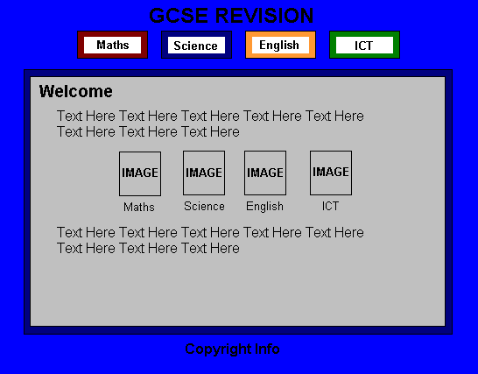

Figure 6-13: The homepage design for Site 3
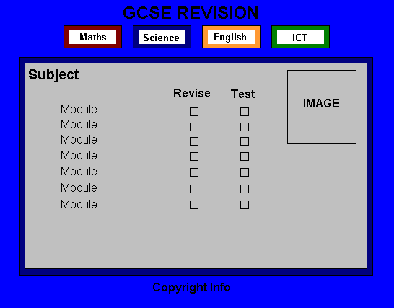

Figure 6-14: Subject page design

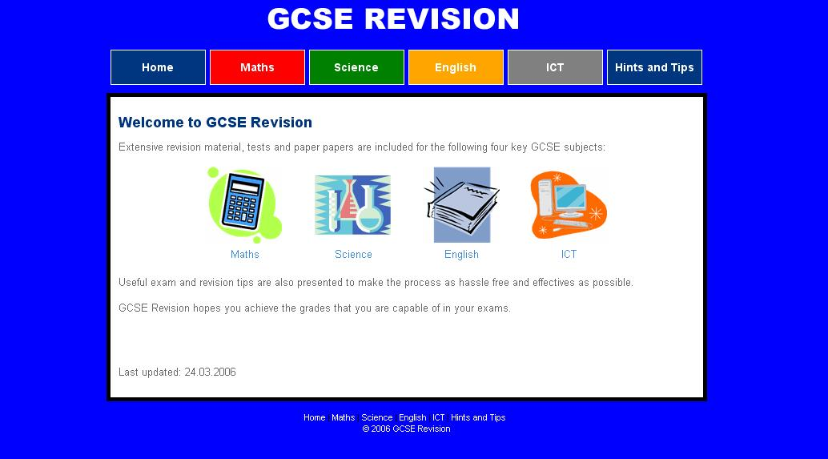

Figure 6-15: The homepage of the implemented Site 3

Site Structure/Code

Adobe Photoshop 7 has been used for editing of the images, while the coding has been done in the code view of Dreamweaver MX 2004 for all the sites. All the sites have been structured in the same basic way using some PHP rather than just HTML, and DIV tags rather than tables have be used for the page layout.

The separation of style from content has been effectively achieved with the well-written CSS and XHTML. The next step involved adding some basic PHP to this mix to take this modularity a step further, making it easier not only to update the styling, but the structure as well. Essentially, the master template uses XHTML for structural markup, CSS for style, and some basic PHP to manage it all. Some very basic work with PHP variables allows the display of different content documents within the same template.

Pages Implemented

Only single instances of all the major types of pages have been implemented and sample/filler content provided where necessary to demonstrate the concepts.

Site 1 | Site 2 | Site 3
Home | Home | Home
About Us | Spec | Maths
FAQ | Mods | Science
Contact | My Car | English
T-Shirts | Your Cars | ICT
T-Shirt Item | Your Cars 1 (details) | Maths Revision Page (for Algebra Foundation & Intermediate)
Shopping Cart | Links | Maths Test Page (for Algebra Foundation & Intermediate)
Checkout (just comments) | Contact | Hints & tips

7 Testing

In order to test the websites effectively, a range of basic testing methods would be used. It is necessary to first validate all xHTML and CSS coding to ensure that they validate correctly before any accessibility issues can be tested reliably. The W3C online validators can be used for this aspect of testing. Secondly WCAG (Web Content Accessibility Guidelines) testing should be carried out by using an online service.

Browser and user display compatibility is another major area that needs to be thoroughly tested as users will be viewing the site with a range of different browsers, monitor sizes and resolutions. Pages need to be tested to see if they are printer-friendly. If not a stylesheet for print media can be used. Some may wish to print a page to read it more comfortably than on-screen. Various accessibility features should be disabled in the browsers to discover if the content is still readable. Features include disabling images, JavaScript, CSS. It is vital that the site can be effectively be viewed by a wide an audience as possible.

All internal and external links needed to be tested and download times need to be analysed for the site. Slow transmission speeds will mean that web sites with a lot of graphics and images will not be viewed as users will get bored and view another site as the download time will be long (Shneiderman, 1997). Users will not tolerate long delays. Usability studies have shown that 8.6 seconds is the maximum time web users will wait for a page to download (King, 2003). However, broadband is now the most common connection type with 64% of all connections in UK now Broadband. [BBC, 2006] Finally all dynamic content needs to be tested such as contact forms and any interaction with databases. This is especially true with the e-shop (Site 1).
It is important to remember that you shouldn’t design for your machine but design for your average reader.

8 Evaluation

The sites would all be subject to a user-centered evaluation by using a sample from their identified user groups. The sample size will be a reasonably low 6-10, but the test doesn't have to be too large. According to usability guru Jakob Nielsen you only need 5 users - after that the results won't improve proportionally. Therefore the sample size will ensure a reliable set of results can be obtained and analysed.

A questionnaire would be given to the user samples to access their qualitative opinions about many aspects of the sites to discover how well they are meeting their needs and requirements.

To begin with, the users would be asked a couple of valuable points about how they would be viewing the site such as their monitor size (if known). Next their first impressions of the sites would be asked for using a maximum of five keywords. They would be set a series of simple tasks to test the ease of information retrieval with the sites. All of the tasks would relate to the users groups task analysis. For example with Site 1 they could be asked to give the standard delivery costs. With Site 2 the users could be asked to provide a technical specification of one of the cars and with Site 3 any of the revision material provided. Tasks would be picked that make the users probe deep into the site to thoroughly test task completion. For each task they would be asked to say how easily they found the answer.

To test the retention of information on the sites, the users would be asked a couple of basic questions without looking back at the site to see if the information was expressed clearly.

Further user evaluation tasks specific to each of the sites would include instructing the users to go through the process of purchasing an item on Site 1 and providing comments about any problems. With Site 2 users would be asked to submit their cars to be put up on the site and provide feedback. On Site 3, the user sample would be asked to go over the revision material for a module and carry out the corresponding test and then provide comments as to how effective the revision process was.

With all the short tasks over, an extensive range of questions would be asked regarding the usability of the sites split into three key sections: Structure/Navigation, Content and Appearance/Presentation. Questions or ratings such as the following would be asked:

- Overall ease of use (1 [confusing, stressful] – 5 [pleasure to use])
- Is the site structure such that it is always clear where you are within the site?
- Rate the quality of information on this site (1 [unacceptable] – 5 [excellent])
- Is the quality and relevance of the graphics effective?
- How aesthetically appealing is the overall site? ([1] not very - [5] extremely)
- Are pages cluttered with not enough white space?

Two final questions would be asked to discover how they felt about the sites after the test using up to five keywords as with their first impressions to allow comparisons. The users would also be asked whether or not they will take any action from viewing the sites; purchasing an item on Site 1, joining and submitting their car on Site 2 and using Site 3 as part of their revision.

References & Bibliography

BBC News (2006) Broadband growth speeds forward; URL http://news.bbc.co.uk/1/hi/technology/4736526.stm [accessed 21st March 2006].
CUergo: Ergonomic Guidelines For User-Interface Design;
URL http://ergo.human.cornell.edu/ahtutorials/interface.html [accessed 3rd March 2006].
Flanders, V. (2005) Web Pages That Suck; URL http://www.webpagesthatsuck.com/
[accessed 3rd March 2006].
King, A.B. (2003) “Speed Up Your Site: Web Site Optimization” : New Riders.
IBM. Ease of Use - Design; URL http://www-306.ibm.com/ibm/easy/eou_ext.nsf/publish/561 [accessed 6th March 2006].

Laudon, K.C.; Traver, C.G. (2004) “E-Commerce: Business, Technology, Society”: Addison-Wesley.

Lynch & Horton. (2002) Web Style Guide, 2nd Edition; URL http://www.webstyleguide.com
[accessed 6th March 2006].
Niederst, P. (1999) “Web Design in a Nutshell” : O’Reilly.
Nielson, J. The Jakob Nielson’s site on usability issues; URL http://www.useit.com/
[accessed 8th March 2006].

Clip Art on Site 3: http://office.microsoft.com/clipart/default.aspx?lc=en-us
Example revision & test material on Site 3: http://www.bbc.co.uk/schools/gcsebitesize/
T-Shirt images on Site 1: http://www.oneposter.com/

